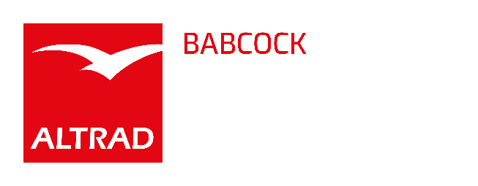
Group Leader - Dynamic Engineering - Permanent Full Time
Location - Renfrew
Competitive salary and benefits
The Asset Management function within Altrad Babcock is a highly specialised engineering services and equipment provider, supporting customers to minimise cost, maximise return and mitigate risk throughout the asset integrity lifecycle.
The Dynamic Engineering team provides specialist consultancy, site measurement, monitoring and analysis services across vibration, structural dynamics, rotating equipment, pipework vibration, fatigue and plant reliability. The team currently operates primarily within oil and gas, with opportunities to grow across power generation, nuclear, renewables, process, petrochemical and wider industrial markets.
We have an opportunity for a Group Leader to lead and develop our Dynamic Engineering team based in Renfrew.
Group Leader - Dynamic Engineering
Profile
Altrad Babcock is seeking a motivated, commercially aware and technically skilled professional to lead our Dynamic Engineering team.
The successful candidate will be responsible for the organisation, development and growth of the team. This will include managing workload and project delivery, supporting technical quality, developing people and actively identifying new opportunities for Dynamic Engineering services.
The role requires someone who can engage confidently with clients, understand their engineering challenges and recognise where vibration, monitoring and dynamic assessment services can add value. You will work closely with internal account teams, site personnel and other engineering disciplines to generate opportunities and build a sustainable pipeline of work.
You will also oversee the effective management of the Dynamic Engineering laboratory, equipment and calibration activities.
Key Responsibilities
Team Leadership and Delivery
- Lead, support and develop engineers, technicians and operational support personnel.
- Plan and manage team workload, resources and priorities.
- Oversee project delivery to ensure quality, cost and schedule requirements are achieved.
- Promote collaboration, accountability and continuous improvement.
- Identify training, succession and capability requirements.
Business Development
- Identify and develop opportunities for Dynamic Engineering services.
- Build relationships with existing and prospective clients.
- Work with internal account teams and other engineering groups to identify cross-selling opportunities.
- Develop and maintain a qualified pipeline of work.
- Translate technical capabilities into clear client-focused services.
- Lead the development of proposals, scopes and cost estimates.
- Support growth into new clients, sectors and markets.
Technical Leadership
- Provide technical leadership across vibration, structural dynamics, rotating equipment, pipework vibration, condition monitoring and fatigue.
- Review technical approaches, analysis, reports and recommendations.
- Support investigations into vibration, resonance, repeated failure and plant reliability issues.
- Ensure relevant codes, standards and good engineering practices are applied.
- Identify new technologies and methods that improve the team’s offering.
Laboratory and Equipment Oversight
- Ensure the Dynamic Engineering laboratory remains safe, organised and suitable for operational needs.
- Oversee the management, calibration, maintenance and availability of equipment.
- Ensure equipment records, asset registers, risk assessments and COSHH requirements are maintained.
- Oversee equipment preparation, mobilisation and shipping for UK, overseas and offshore work.
Client and Stakeholder Collaboration
- Build and maintain relationships with internal and external stakeholders.
- Represent Altrad Babcock in client meetings, technical discussions and project reviews.
- Work with colleagues across Integrity Engineering, Plant Operations, Project Engineering, Design Engineering, NDT, Metallurgy and other relevant disciplines.
- Support the delivery of integrated engineering solutions.
Job Requirements
- Degree-qualified in Mechanical Engineering, Structural Engineering or a related discipline.
- Chartered Engineer status or equivalent is advantageous but not essential.
- Relevant experience in vibration, structural dynamics, rotating equipment, pipework vibration, condition monitoring, fatigue or a related discipline.
- Experience leading engineering teams, projects or technical work packages.
- Strong client-facing and stakeholder management skills.
- Commercial awareness with experience supporting proposals, business development or account growth.
- Ability to identify client requirements and convert them into defined scopes of work.
- Knowledge of relevant measurement equipment, sensors, data acquisition systems and monitoring techniques.
- Experience within oil and gas, power generation, nuclear, process, petrochemical, renewables or infrastructure would be beneficial.
- Familiarity with relevant engineering analysis software would be advantageous.
Typical Duties
- Lead the Dynamic Engineering team and manage workload, priorities and resources.
- Engage with clients and internal stakeholders to identify new work.
- Develop and review proposals, scopes and cost estimates.
- Manage projects, including cost, schedule, resource and technical delivery.
- Review vibration surveys, monitoring data, engineering analysis and technical reports.
- Support root cause investigations and the development of practical recommendations.
- Oversee laboratory, equipment and calibration activities.
- Monitor team utilisation, project performance and opportunity development.
- Identify training, recruitment and development requirements.
- Support the wider Integrity Engineering Department and Asset Management business as required.
The Ideal Candidate
You are a technically credible and commercially minded engineering professional with the ability to lead and organise a specialist team.
You will be confident engaging with clients, understanding their engineering challenges and identifying where Dynamic Engineering can provide value. You will be comfortable taking ownership of the team’s future workload and actively developing opportunities.
Experience in vibration, structural dynamics, rotating equipment, pipework vibration, condition monitoring or fatigue assessment will provide a strong advantage.
Join Us
Altrad Babcock welcomes applications from talented individuals who want to lead, develop and grow a specialist engineering team.
If you are ready to take ownership of a technically challenging and commercially important area of our Asset Management business, apply today.

